Enterprise Rental Checklist

☐ Determine Employee vs. Non-Employee Status for Renting Off State Contract
- If State employee, continue with checklist.
- If RF employee, student, on leave, or other non-employee, do not continue with checklist (as a rental is not permitted using SUNY Cortland’s account).
  - If unsure, check here: https://www2.cortland.edu/offices/purchasing-office/travel-guidelines/#car-rentals.

☐ Call Travel Administrator at ext. 2306
☐ Request campus account number and billing number (for direct billing).
  - Travelers should not be providing their personal credit cards at time of rental.

☐ Complete Travel Authorization for traveler
- Must be fully approved and filed with Travel Administrator prior to trip.

☐ Reserving a Vehicle
☐ Link to Enterprise online renting for government employees
Enter account # (provided by Travel Administrator) under “Corporate Account Number” (shown below).
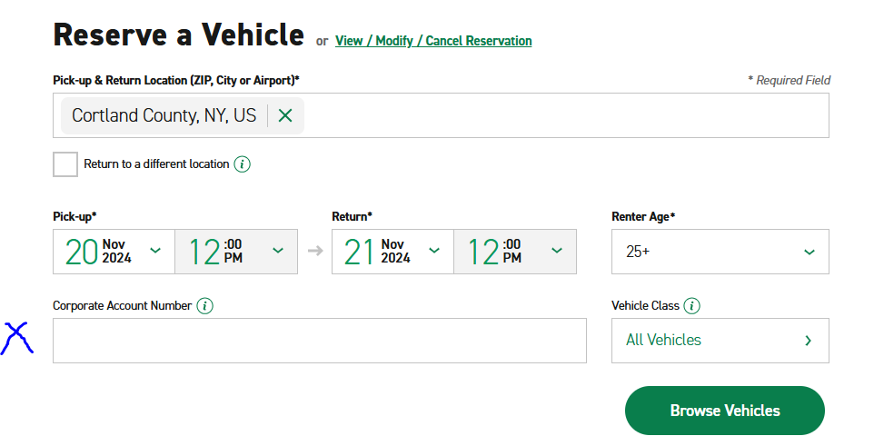
☐ Select Vehicle Class to filter by size
    - Choose Economy/Compact size
    - If Standard/Intermediate/Full-size are selected, written justification must be provided with invoice/PO.
    - Any size larger than Standard/Intermediate/Full-size requires prior approval by Travel Administrator and that written approval must be provided with invoice/PO.
      - Failure to obtain prior approval will result in the traveler paying the difference of the larger vehicle out of their own pocket.
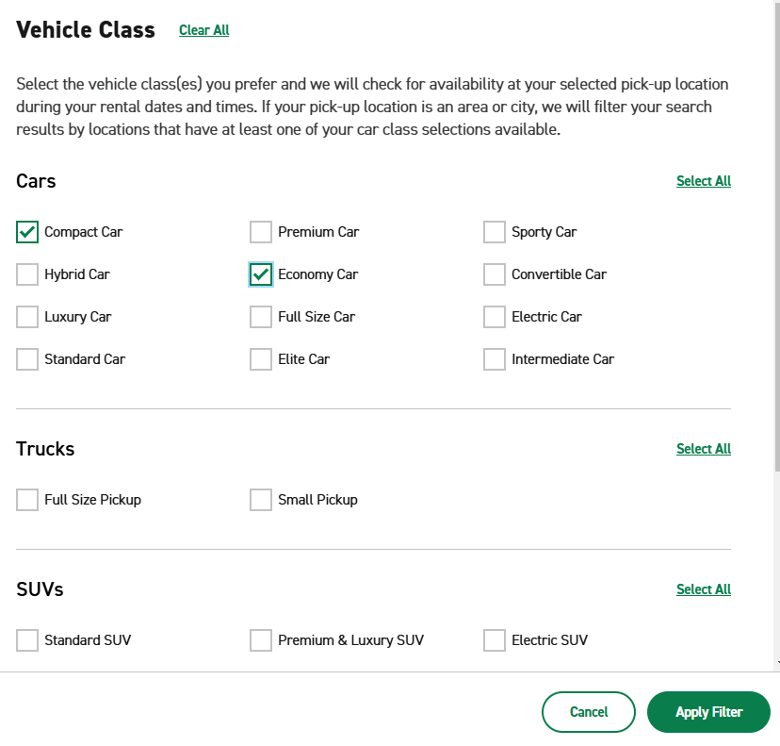
☐ Click “Apply Filter”
☐ Click “Browse Vehicles”
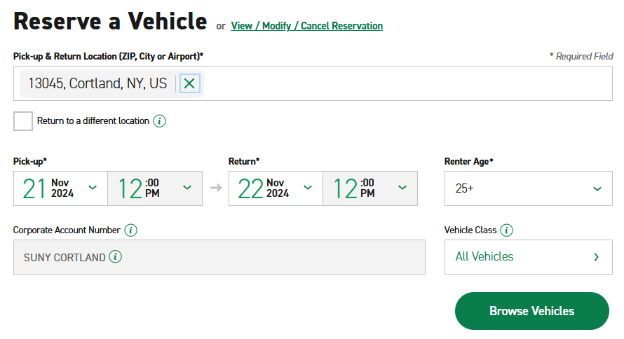

☐ Choose a Location and click “Select”
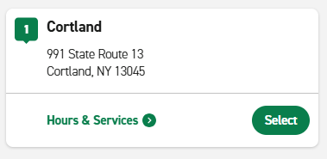

☐ Click “Select” on vehicle of choice
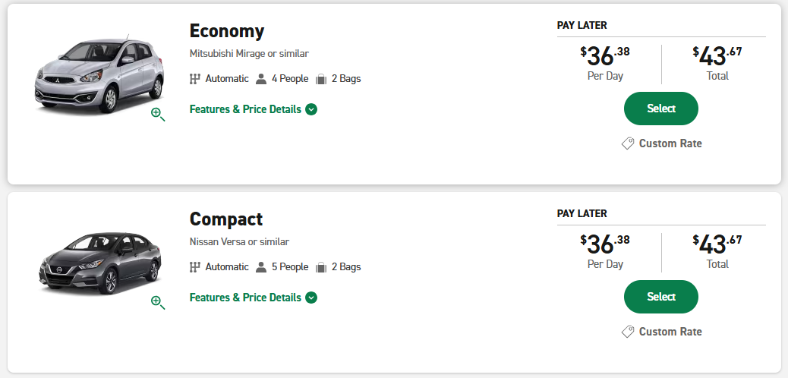

☐ Extras
- Do NOT add any extras (i.e. Sirius XM, Greenhouse Gas Emissions Offset, Insurance, etc.)
☐ Click “Continue to Review”
☐ Review & Reserve
- Contact Details
☐ Enter Traveler’s Contact Details (first & last name, phone #, & email)
☐ Confirm Trip Purpose (check box to acknowledge travel is on behalf of the university)
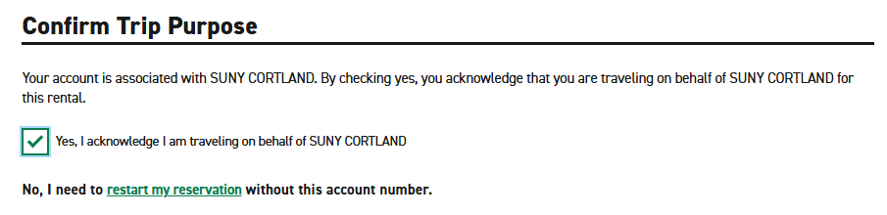
☐ Billing
☐ Select “Yes” for direct billing
☐ Enter Billing Number (provided by Travel Administrator)

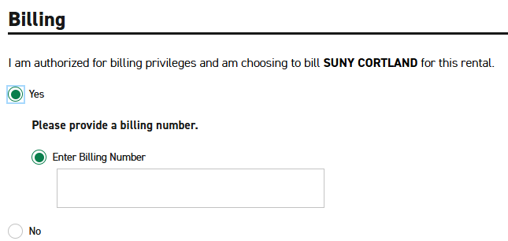

☐ Additional Details
☐ Enter Department (of Traveler)
☐ Enter the name of the person requesting the reservation (if different than the traveler)

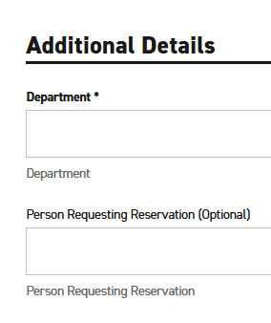
☐ Save Time At The Counter (Optional)
- This sectional is optional if the traveler is completing the reservation and would like to provide their Driver’s License information at this time.
- Otherwise, select “No”.

☐ Click “Reserve Now”
- Note: At the top of the screen, the following message will appear stating that tax will be removed at the time of rental.
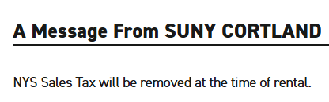

Reasons to book online vs. calling local office:
  - Automatic tax exemption online
  - Emailed confirmation of rental
  - Department and contact information ensured to appear on billing statement for invoice(s)

☐ Upon Returning from Trip
☐ Accounts Payable will email invoice(s) to Dept. AA based on dept. & contact information on billing statement from Enterprise.
  - Dept. AA will:
☐ Review invoice to ensure there is no tax and everything is correct.
☐ Create a PO in RDD and attach invoice (1 invoice/PO, per NOR Policy) and, if applicable, justification for any vehicle size larger than Compact/Economy or approval from Travel Administrator for any size larger than Standard/Intermediate/Full-size.
☐ Upon final approval of PO, go back into PO and receive & close the PO.
      - This allows AP to pay the invoice.
  - For those departments/offices with a standing Enterprise PO for the fiscal year, once you receive the invoice from AP, go into RDD and receive that amount against your standing PO.
☐ Reply to AP with receiving completed against RDD PO, and, if applicable, attach justification to the email for any vehicle size larger than Compact/Economy or approval from Travel Administrator for any size larger than Standard/Intermediate/Full-size.

Vehicle codes on invoice (to know if you need justification for a larger vehicle than Economy/Compact):
